**Course Project – Air and Water**

Shaun Pritchard

Rasmussen College

G328/EVR3410

Marshall Bowles

June 05, 2020

**Course Project – Air and Water**

**Do you believe that the United States should commit to the Paris Agreement? What arguments most influenced your decision?**

I would like to state an argument before jumping into the thesis of the Paris Climate Agreement. To say that I agree that we need a universal agreement, but one that is that is actionable to solving real environmental issues with real viable Solutions. I believe we have reached a tipping point that is unsafe regarding our planet’s future and our environment.  Also, a unified agreement as such would need to be fair, truthful, honest, and hold each nation equally accountable without favoritism. The agreement should also have a premise-based on science, logic, fact, and reasoning, not politics. I do not think the Paris Agreement facilitates any of these notions. Before explaining I would like to show some facts to support my argument.

As a student of Science aspiring to be a data & math scientist specifically. I find relevancy in the process of due diligence, researching, and studying. The face value and mainstream narratives would suggest that the Paris agreement facilitates the change that we are all wanting. After reading the Paris agreement and many other supporting factual documents my concussion is to reject the notion of the Paris agreement. Here is the latest data that shows the level of co2 emissions:

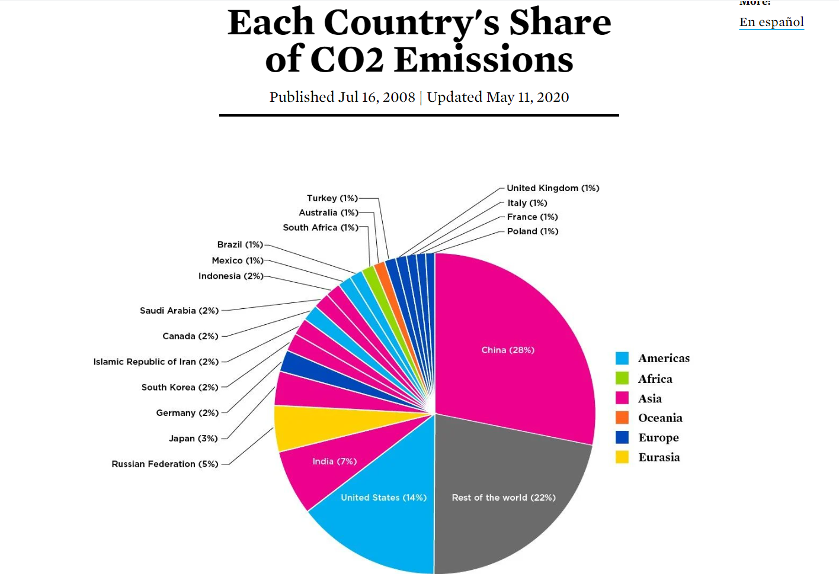

CO2 emissions for each country in 2020 *(UCSUSA, 2020)*. China leads as the number one most pollutant country on the planet followed by India, the United States of America, Russia, Japan, and so on.

  China accounts for 28% over a quarter and nearly half of the world's co2 emissions because of unchecked Industry growth that has become seriously dangerous to this planet. Polluting more than any other country in the world *(Active Sustainability, 2020)*. China also has levels of air pollution in its cities that cause 350,000–400,000 premature deaths per year. Another 300,000 died because of indoor air of poor quality *(Wikipedia, 2020)*. There were 60,000 premature deaths each year because of water pollution, industrial runoff, and poor air quality *(Climate Action Tracker, 2020)*. China is also listed as the world’s deadliest country for outdoor air pollution, according to an analysis by the World Health Organization (WHO) *(The Guardian, 2016)*. The USA follows suite not because of manufacturing an industry growth but because of western civilization-based consumer habits and industry at 17% co2 emissions. India like China has unchecked non-regulation-based industries and no accountability for the environment, runoff, or local habitats. accounting for 7% co2 emissions on the planet *(Ceasepollution.com, 2020)*. India is also on the list of the most polluted cities in the world. As per a study based on 2016 data, at least 140 million people in India breathe air that is 10 times or more over the W.H.O safe limit *(Newsy.com, 2020)*.

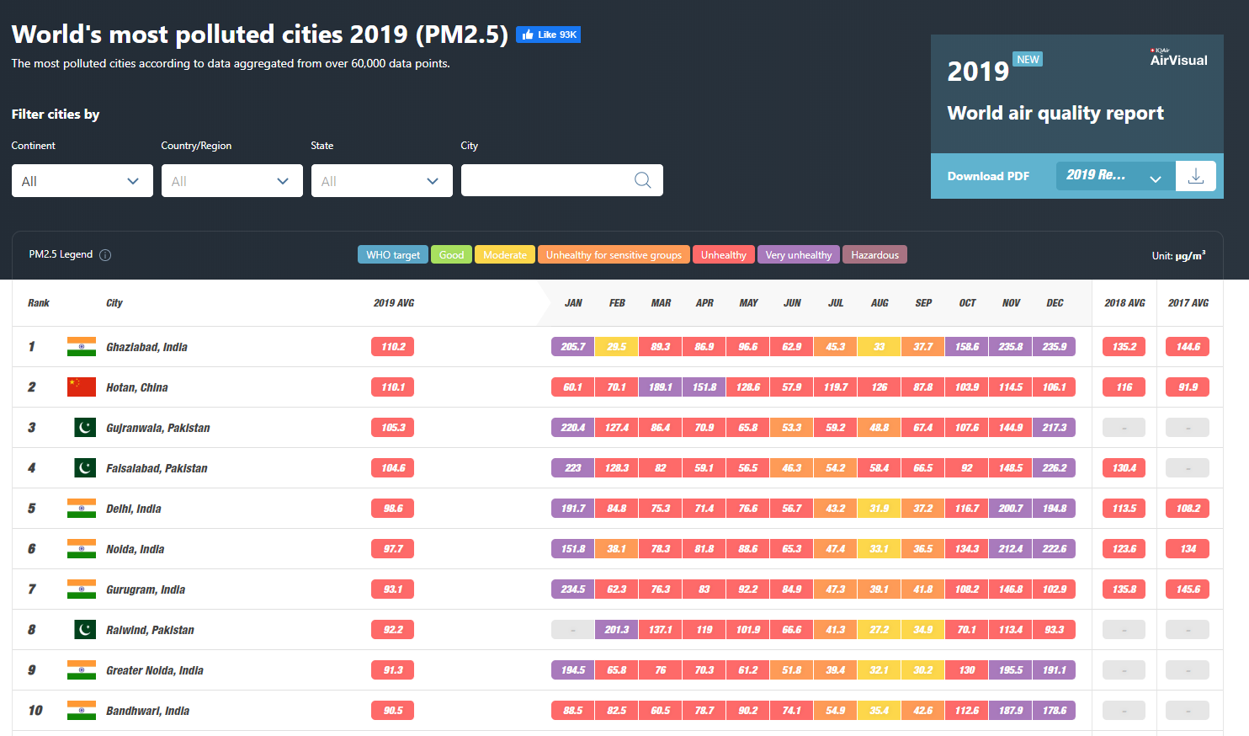

The data above is to discern a point and simply show that America does not stand alone as being the only co2 emitting country let alone the only dangerous polluting country on the planet *(IQAIR, 2020)*. Also, it not the worst in comparison to other countries like China and India.

A climate agreement should be based on actionable regulation to all countries equally involved. To tackle the diverse issues of climate change and pollution with viable resolutions. The Paris agreement does not facilitate really actionable, oversight, or pragmatic solutions. The Paris climate agreement was deeply flawed from its start. It was legally and constitutionally suspect, based on politics rather than science, facts, and contained unrealistic goals. It promised not only a dramatic expansion of the administrative state and a huge increase in the regulatory burden on American businesses, but it also threatened to put the brakes on U.S. economic output at a time when most economists think the U.S. will struggle to achieve even a meager two percent growth *(Heritiage.org, 2017).*

The Paris agreement would allow China to be able to increase its emissions and continue to develop new industries without regulations completely unchecked for the next 13 years with capacity building implementations in article 11 of the accord *(unfcc, 2015).* India and other developing countries can only contribute to the agreement with foreign aid from America, not China or Russia. By contrast, China committed to boosting non-fossil fuels to around 20% of its overall energy by 2030, but China’s Emissions have grown exponentially since the Paris Agreement was signed in 2015 *(Pew Research Center, 2015)*. due implementing more usage of non-renewable coal sources. China’s CO2 emissions grew faster in 2018 than the 1.7% growth in 2017, according to studies *(Carbonbrief.org, 2019)*. While America's emissions have decreased by 0.3% *(Climateactiontracker.org, 2020)*.

The Paris agreement was an attempt to halt climate change on the honor system. Its only legal requirements were for signatories to announce goals and report progress, with no international enforcement mechanism. As a result, it was likely that the United States and wealthy European nations would have adopted and implemented severe climate change rules while many of the world’s governments would avoid doing anything that would slow their economies as proved since 2015.

The Paris Agreement is highly cost to the American people and would not prove to yield the results anticipated through the initiative in addressing climate change. The regulations necessary to implement the Paris agreement would have cost the U.S. industrial sector 1.1 million jobs, according to a study commissioned by the U.S. Chamber of Commerce. The Heritage Foundation study found that the Paris agreement would have increased the electricity costs of an American family of four by between 13% and 20% annually. It forecast a loss of income of $20,000 by 2035. In other words, American families would be paying more while making less *(Heritiage.org, 2017)*.

The overall effect of the agreement would have been to reduce U.S. GDP by over $2.5 trillion and eliminate 400,000 jobs by 2035, according to Heritage’s study *(Heritiage.org, 2017)*. This would exacerbate problems with government funding and deficits, make Social Security solvency more challenging, and increase reliance on the government’s spending to support households. The Paris conference, participants called for a Green Climate Fund that would collect $100 billion per year by 2020 *(American Thinker, 2018)*. This is only what American taxpayers would have had to pay. While other countries were not under any terms to contribute funds. There are also stipulations about the United Nations and Conference of the Parties based on the U.N which would extend sovereign authority and authority into America.

After studying the agreement and researching many opposing, contradictory, and supporting arguments *(unfcc, 2015).* I believe the initiative is on the right track, but there's just too many holes in the agreement, no accountability, no commutative correlation to bind countries together equally, and the burdens of resources and finances weigh too heavy on America as opposed to the other leading countries.

I believe we need an agreement in place with real actionable milestones to achieve real actionable goals to tackle this problem. There needs to be some oversight that does not burden the people of select nations, but the industries which are solely responsible for causing the harm in the first place. Maybe more incentive, innovation, and collaboration with a system in place that shares responsibility accordingly and evenly amounts to the top and developing countries? I honestly think we can do a lot better if we come together without the bureaucracy, red tape, and politics.

**Do you believe that we will experience significant global warming during this century due to air pollution? In what way would the Paris Agreement impact your position on global warming?**

I do believe that we were going to see significant impacts of global warming during this century not only because of air pollution but because of Industrial Waste, runoff, ocean's, resources, water supplies, and many other unsustainable factors. I think we have made a very big mess out of everything as did the people over the last few centuries. We need some accountability, action, and solutions, not sediments built on unwavering political tension and distrust. As individuals in a free country, we can discern certain reasoning and logic and be accountable for ourselves. I think as a country we need to set some examples. I also believe that other countries should be 100% all-in as well *(Breitbart, 2017)*.

This planet belongs to all of us. I believe we should be using data to design systems in aiding and helping not only our country but other countries to build and implementing viable solutions. Allocating resources while working with the leaders of all the countries to work on real problems. I think we need a federation that proves facts or false narratives and media hype. Science And scientists should lead the way to an initiative based on real viable innovation and solutions.

The Paris accord as it stands does not compromise or facilitate actionable steps to real change without causing negative economic impact and unaccountability of nations while exploiting others. I believe we need something more substantial that is worked on hand in hand with world leaders and those who support the initiative of environmental impact. I also believe the facts science has proven over history and I do not believe in fearmongering or pandering for just one questionable agreement that is political driven. We need actionable solutions to fix problems.

I find several scientific findings and facts very that contradictory based on some of these Notions. First being how several billion years ago we have found 900 dinosaur’s species that we know of which could by properties of mass and laws of physics have accounted for an exponentially larger amount of living creatures compared to 8 billion humans here on earth today? No, they did not have industry back then but still a much larger carbon based lifeforms who naturally let out more CO2 emissions at a larger rate and volumes in comparison to humans, Volcanic activity was greater, The cooling of the planet, the ice age, poles shifting, and the earth sustaining itself for several thousand years off and on for millennia. Until life regenerated time and time again on the surface. We know these things happened and that they are possibilities for our future. Our actions as humans on this planet are despicable and grotesque, to say the least. Also, the Ozone gets pounded by the sun's deadly rays every day which is way more dangerous, harsh, explosive, and corrosive then co2. So how is that co2 can deplete something more than the harsh deadly burst of solar flares and the vacuum of space?

My point being is that while things may occur on our planet not everything is within our meek human control. We might see changes on this planet due to our presence and our lack of respect for the environment, but nothing we do short of a nuclear apocalypse is going to compare to what history is already done let alone knock the Earth off its orbit and destroy the whole planet. The planet will be here long after we are gone. We need to fix these issues in agreement with compromise and resolution so we can stay here longer and secure our future and the other species on this planet’s future. This will take discourse, science, faith, and action in my opinion.

I do want to point out I am not being apologetic for what we have done to this planet and I deeply believe we need to figure this out very soon. The only way we are going to do this is by setting politics and agendas aside to focus on the real problems eating away at this planet. Heal them to be sustainable and find our true balance in nature.

**What is the effect of global warming on Earth's water resources?**

As far as we know, is that we have only been 7 miles down on earth's surface out of 2000 + miles. We are depleting the natural water sources. While the warming of the planet is destroying the fragile balance of every living system on this planet. Making ice sheets melt and grow *(NASA, 2015*), water levels in the oceans rise, deadly storms, chaos, and destructive weather has arisen *(NASA, 2015).* The effect of global warming on Earth's water resources is detrimental.

# References

Active Sustainability. (2020). *Top 5 most polluting countries*. Retrieved from www.activesustainability.com: https://www.activesustainability.com/environment/top-5-most-polluting-countries/

American Thinker. (2018, 12 31). *China and the Paris Accord*. Retrieved from https://www.americanthinker.com: https://www.americanthinker.com/blog/2018/12/china_and_the_paris_accord.html

Breitbart. (2017, 06 1). *Top 7 Worst Reasons to Keep the Paris Climate Accord*. Retrieved from https://www.breitbart.com: https://www.breitbart.com/politics/2017/06/01/top-7-worst-reasons-keep-paris-climate-accord/

Carbonbrief.org. (2019, 03 5). *China’s CO2 emissions grew slower than expected in 2018*. Retrieved from https://www.carbonbrief.org: https://www.carbonbrief.org/guest-post-chinas-co2-emissions-grew-slower-than-expected-in-2018

Ceasepollution.com. (2020). *Top 10 Biggest Polluters in The World*. Retrieved from https://ceasepollution.com/: https://ceasepollution.com/top-10-biggest-polluters-in-the-world

Climate Action Tracker. (2020). *China Climate Action Tracker*. Retrieved from https://climateactiontracker.org: https://climateactiontracker.org/countries/china/

Climateactiontracker.org. (2020). *USA*. Retrieved from https://climateactiontracker.org: https://climateactiontracker.org/countries/usa/

Heritiage.org. (2017, 06 01). *4 Reasons Trump Was Right to Pull Out of the Paris Agreement*. Retrieved from https://www.heritage.org: https://www.heritage.org/environment/commentary/4-reasons-trump-was-right-pull-out-the-paris-agreement

IQAIR. (2020). *World's most polluted cities 2019 (PM2.5)*. Retrieved from https://www.iqair.com: https://www.iqair.com/world-most-polluted-cities

NASA. (2015, 10 30). *NASA Study: Mass Gains of Antarctic Ice Sheet Greater than Losses*. Retrieved from www.nasa.gov: https://www.nasa.gov/feature/goddard/nasa-study-mass-gains-of-antarctic-ice-sheet-greater-than-losses

Newsy.com. (2020, 02 25). *1 Of Top 30 Air Polluted Cities Last Year Were In India*. Retrieved from newsy.com: 1 Of Top 30 Air Polluted Cities Last Year Were In India

Pew Research Center. (2015, 10 24). *Corruption, Pollution, Inequality Are Top Concerns in China*. Retrieved from https://www.pewresearch.org: https://www.pewresearch.org/global/2015/09/24/corruption-pollution-inequality-are-top-concerns-in-china/

The Guardian. (2016, 10 27). *China tops WHO list for deadly outdoor air pollution*. Retrieved from https://www.theguardian.com: https://www.theguardian.com/environment/2016/sep/27/more-than-million-died-due-air-pollution-china-one-year

UCSUSA. (2020, 04 11). *Each Country's Share of CO2 Emissions*. Retrieved from https://www.ucsusa.org: https://www.ucsusa.org/resources/each-countrys-share-co2-emissions

unfcc. (2015). *The Paris Agreement*. Retrieved from unfcc.int: https://unfccc.int/files/essential_background/convention/application/pdf/english_paris_agreement.pdf

Wikipedia. (2020). *Pollution in China*. Retrieved from https://en.wikipedia.org: https://en.wikipedia.org/wiki/Pollution_in_China#:~:text=High%20levels%20of%20air%20pollution,of%20water%20of%20poor%20quality.&text=China%20has%20made%20some%20improvements%20in%20environmental%20protection%20during%20recent%20years.